**SPRINT – 3 DEVELOPMENT OF PYTHON SCRIPT**

| Date | 15 November 2022 |
| --- | --- |
| Team ID | PNT2022TMID35844 |
| Project Name | IoT Based Smart Crop Protection System for Agriculture |

**DESCRIPTION :**

The random sensor data’s are generated and automation has been implemented through the python code to implement IoT based crop protection system. And the code gives the response to the IoT Device in IBM Watson Platform.

**PYTHON CODE :**

#include <WiFi.h>//library for wifi

#include <PubSubClient.h>//library for MQtt

#include "DHT.h"// Library for dht11

#define DHTPIN 15 // what pin we're connected to

#define DHTTYPE DHT22 // define type of sensor DHT 11

#define LED 2

float floatMap(float x, float in_min, float in_max, float out_min, float out_max) {

return (x - in_min) * (out_max - out_min) / (in_max - in_min) + out_min;

}

DHT dht (DHTPIN, DHTTYPE);// creating the instance by passing pin and typr of dht connected

void callback(char* subscribetopic, byte* payload, unsigned int payloadLength);

//-------credentials of IBM Accounts------

#define ORG "wckx64"//IBM ORGANITION ID

#define DEVICE_TYPE "ibmiot"//Device type mentioned in ibm watson IOT Platform

#define DEVICE_ID "1234"//Device ID mentioned in ibm watson IOT Platform

#define TOKEN "12345678" //Token

String data3;

float h, t;

//-------- Customise the above values --------

char server[] = ORG ".messaging.internetofthings.ibmcloud.com";// Server Name

char publishTopic[] = "iot-2/evt/Data/fmt/json";// topic name and type of event perform and format in which data to be send

char subscribetopic[] = "iot-2/cmd/command/fmt/String";// cmd REPRESENT command type AND COMMAND IS TEST OF FORMAT STRING

char authMethod[] = "use-token-auth";// authentication method

char token[] = TOKEN;

char clientId[] = "d:" ORG ":" DEVICE_TYPE ":" DEVICE_ID;//client id

//-----------------------------------------

WiFiClient wifiClient; // creating the instance for wificlient

PubSubClient client(server, 1883, callback ,wifiClient); //calling the predefined client id by passing parameter like server id,portand wificredential

void setup()// configureing the ESP32

{

**Serial**.begin(115200);

dht.begin();

pinMode(LED,OUTPUT);

delay(10);

**Serial**.println();

wificonnect();

mqttconnect();

}

void loop()// Recursive Function

{

h = dht.readHumidity();

t = dht.readTemperature();

int analogValue = analogRead(35);

float voltage = floatMap(analogValue, 0, 4095, 0, 14);

delay(1000);

**Serial**.print("temp:");

**Serial**.println(t);

**Serial**.print("Humid:");

**Serial**.println(h);

**Serial**.print(" ph value ");

**Serial**.println(voltage);

PublishData(t);

PublishData1(h);

PublishData2(voltage);

delay(1000);

if (!client.loop()) {

mqttconnect();

}

}

/*.....................................retrieving to Cloud...............................*/

void PublishData(float temp)

{

mqttconnect();//function call for connecting to ibm

/*

creating the String in in form JSon to update the data to ibm cloud

*/

String payload = "{\"temp\":";

payload += temp;

payload += "}";

**Serial**.print("Sending payload: ");

**Serial**.println(payload);

if (client.publish(publishTopic, (char*) payload.c_str())) {

**Serial**.println("Publish ok");// if it sucessfully upload data on the cloud then it will print publish ok in Serial monitor or else it will print publish failed

} else {

**Serial**.println("Publish failed");

}

}

void PublishData1( float humid) {

mqttconnect();//function call for connecting to ibm

/*

creating the String in in form JSon to update the data to ibm cloud

*/

String payload = "{\"Humid\":";

payload += humid;

payload += "}";

**Serial**.print("Sending payload: ");

**Serial**.println(payload);

if (client.publish(publishTopic, (char*) payload.c_str())) {

**Serial**.println("Publish ok");// if it sucessfully upload data on the cloud then it will print publish ok in Serial monitor or else it will print publish failed

} else {

**Serial**.println("Publish failed");

}

}

void PublishData2(float voltage) {

mqttconnect();//function call for connecting to ibm

/*

creating the String in in form JSon to update the data to ibm cloud

*/

String payload = "{\"pH\":";

payload += voltage;

payload += "}";

**Serial**.print("Sending payload: ");

**Serial**.println(payload);

if (client.publish(publishTopic, (char*) payload.c_str())) {

**Serial**.println("Publish ok");// if it sucessfully upload data on the cloud then it will print publish ok in Serial monitor or else it will print publish failed

} else {

**Serial**.println("Publish failed");

}

}

void mqttconnect() {

if (!client.connected()) {

**Serial**.print("Reconnecting client to ");

**Serial**.println(server);

while (!!!client.connect(clientId, authMethod, token)) {

**Serial**.print(".");

delay(500);

}

initManagedDevice();

**Serial**.println();

}

}

void wificonnect() //function defination for wificonnect

{

**Serial**.println();

**Serial**.print("Connecting to ");

WiFi.begin("Wokwi-GUEST", "", 6);//passing the wifi credentials to establish the connection

while (WiFi.status() != WL_CONNECTED) {

delay(500);

**Serial**.print(".");

}

**Serial**.println("");

**Serial**.println("WiFi connected");

**Serial**.println("IP address: ");

**Serial**.println(WiFi.localIP());

}

void initManagedDevice() {

if (client.subscribe(subscribetopic)) {

**Serial**.println((subscribetopic));

**Serial**.println("subscribe to cmd OK");

} else {

**Serial**.println("subscribe to cmd FAILED");

}

}

void callback(char* subscribetopic, byte* payload, unsigned int payloadLength)

{

**Serial**.print("callback invoked for topic: ");

**Serial**.println(subscribetopic);

for (int i = 0; i < payloadLength; i++) {

//Serial.print((char)payload[i]);

data3 += (char)payload[i];

}

**Serial**.println("data: "+ data3);

if(data3=="lighton")

{

**Serial**.println(data3);

digitalWrite(LED,HIGH);

}

else

{

**Serial**.println(data3);

digitalWrite(LED,LOW);

}

data3="";

}

**CONNECTION DIAGRAM :**

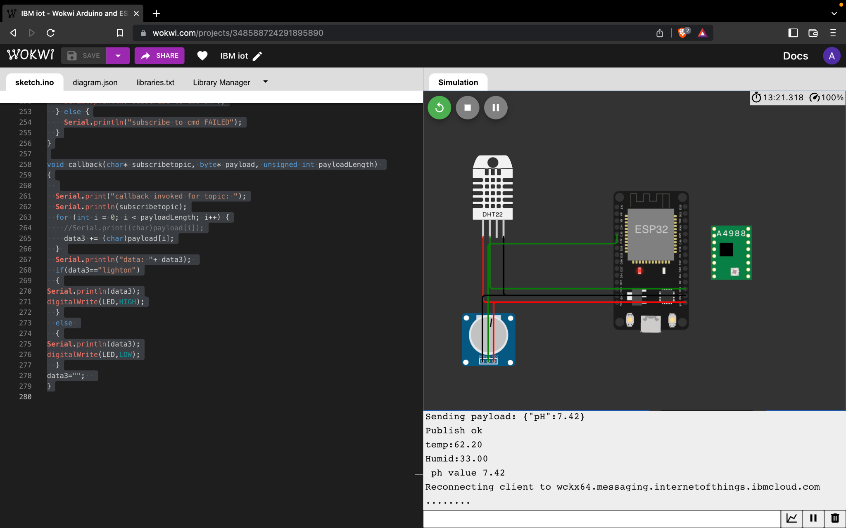

**OUTPUT IN IBM WATSON IoT PLATFORM**



